**Name: _____________________ /35**

**2020 Yr 12 ATAR Physics Task One**

**BLOCK LETTER: ____________**

**Aim: To calculate and compare the static frictional force between the rough and smooth sides of a block of wood on a plane inclined at 300 to the horizontal**.

**Diagram**

Equipment Available:

* Inclined plane with pulley
* Small bucket
* Electronic balance
* Sand
* String
* Rulers
* Protractors
* Wooden block with sand paper glued on one side

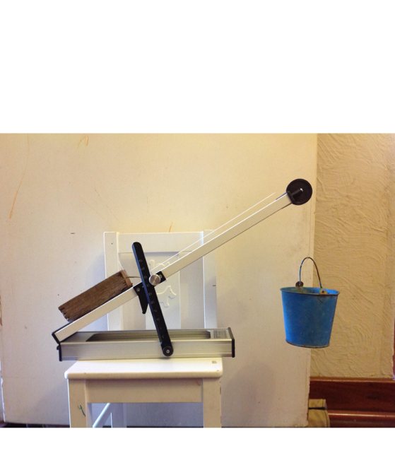

**Instructions**

* Set up the inclined plane so that is angled at 300 to the horizontal.
* Collect a wooden block, note its letter on the front page of this booklet, then measure and record the mass of the block.
* Cut some string and attach one end to the hook in the wooden block, tie the other end around the small bucket and align the string over the pulley, laying the block **smooth** side down on the plane.
* **Gently / slowly** add sand to the small bucket until the block just starts to slide. Stop the system, take out some sand, then slowly add sand **even more gently / slowly** until the block just starts to move.
* Measure and record the total mass of the bucket and sand.
* Conduct repeat trials.
* Flip the block over and repeat the process for the sandpapered side.
* Be careful with your significant figures – consider how many sig figs that you can actually measure to.

**RESULTS** (Construct your results table in the space below) **(5 marks)**

**DIAGRAMS & CALCULATIONS (10 marks)**

(Sketch two free body diagrams – one for the average of the results of the smooth situation and one for the average of the results of the rough situations, showing all values. Then complete fully worked calculations for these averages to show how you arrived at a value for the static friction in each situation).

**Values for static friction**: Smooth __________________ Rough ________________ **(2 marks)**

Explain why the value of the static frictional force between the rough side and the plane is much larger than between the smooth side and the plane. **(2 marks)**

**RELIABILITY**: (Comment on the similarity, or lack thereof, of your repeat trials and determine the percentage variation of the trials from the average) **(4 marks)**

**UNCERTAINTY (**Determine the absolute uncertainty of the value of the static frictional force between the block and the plane for the smooth situation**). (6 marks)**

**CONCEPT QUESTION**  (6 marks)

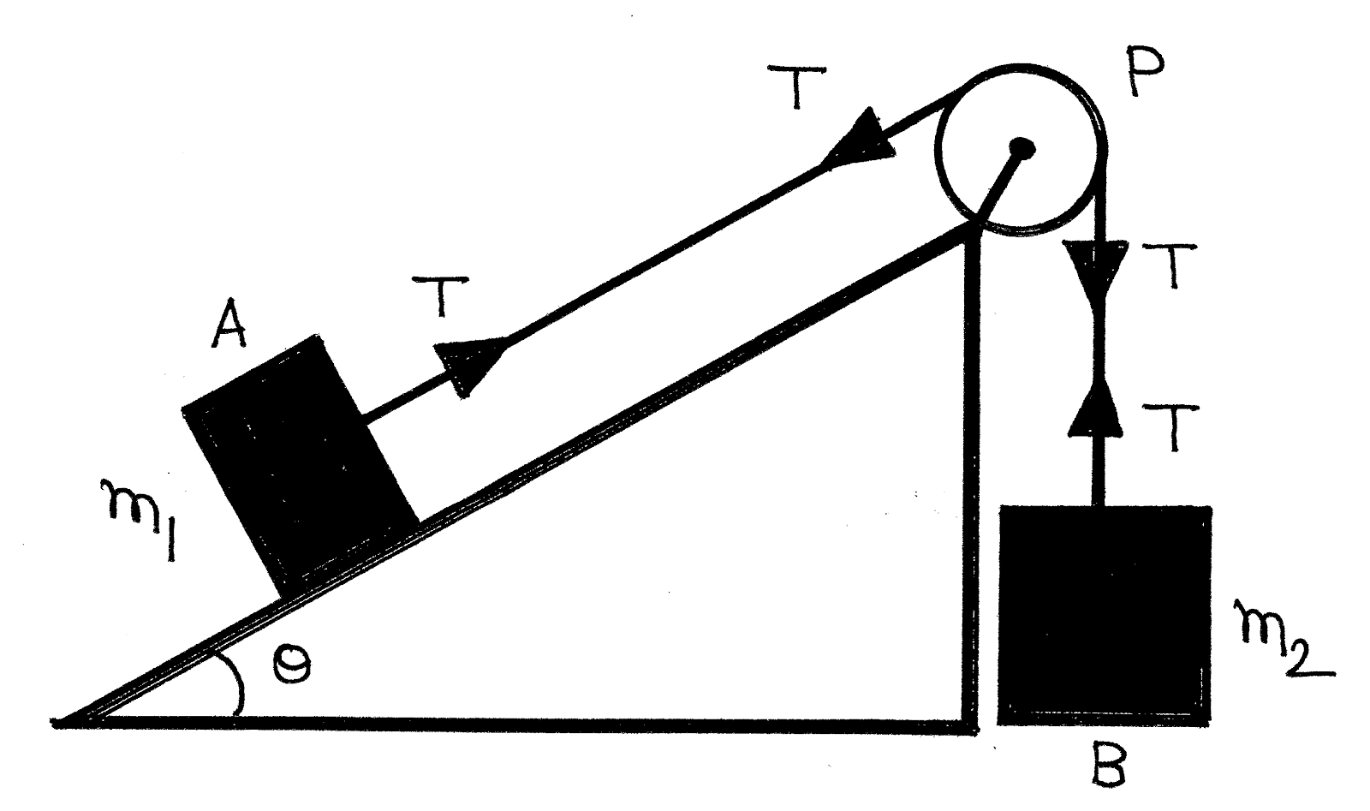

The diagram on the left shows box A, of mass 0.250kg accelerating up a frictionless slope, which is inclined at 35.00 to the horizontal.

1. In the space below sketch a free body diagram, showing all of the **real** forces acting on box A. (2 marks)

b) If the slope is frictionless, and the mass of B is 0.750kg, determine the tension in the cable. (4 marks)